# **SOIL ANALYSIS AND CROP RECOMMENDATION SYSTEM**

**THE IOT SECTION**

It is effective and efficient to adopt our IOT system rather than using other tools like Spectra analysis which is very expensive considering the price of spectrometer and there is no supplier of such tool in our country in addition to that spectrometer has approximately 60-70% accuracy hence the approach of our system that uses Arduino sensors why? It is a cheap, portable, and very accurate.

CURRENT STATE

Currently our agricultural research centers use soil sampling method to measure soil nutrient contents and Soil PH, in one of our interactive session a student from Bunda college of Agriculture which is one of the Agriculture research station in Malawi said “During lab Analysis they use a soil PH meter and titration to extract chemicals from soil samples and other methods ” which takes a lot of time to get the results however with sensors and Arduino all these (Soil PH and available Chemicals like N,P and K) are displayed at once, within seconds. And according to A Chemist Major “Chemical reactions occurs when chemicals are exposed to air or moisture for example Oxidation reaction, altering the availability of certain nutrients or affecting PH levels. Not only that, Soil contains Microorganisms, microbial activity can occur during transit, leading to changes in nutrient levels” according to this information Soil Compositions are bond to changes in transit to the Lab hence contributing to inaccurate results.

***Components Required***

* Arduino Uno board
* Soil NPK sensor
* Calcium Sensor
* Soil Temperature sensor
* LCD display
* Jumper Wires
* A Potentiometer
* Resistor
* Bread Board
* Soil PH sensor
* Calcium. Magnesium and Sulphur sensor

Stage 0

1. Tools and Components
2. Available Resources: Arduino Uno board, Bread board, LCD Display, Jumper Wires, Resistors, Potentiometer, Soil Temperature Sensor, Iron solder and power Adapter.
3. Testing
4. Calibrating and Checking if all components are functional and producing collect results the following code from Arduino library Examples is used to test the LCD, wires and resistors. <http://www.arduino.cc/en/Tutorial/LiquidCrystalHelloWorld>

***Below are Pictures Showing Result of Testing and the soldering process***

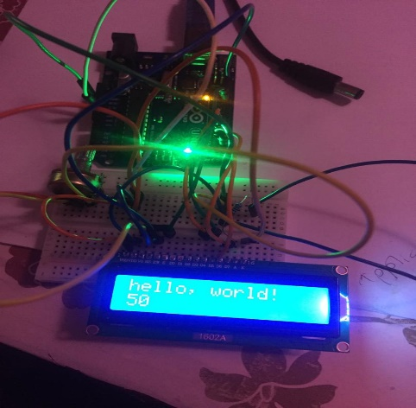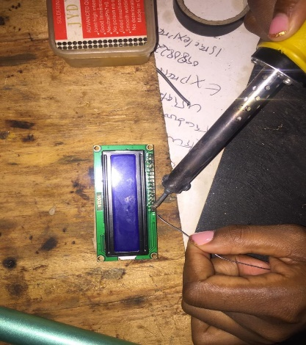

1. Implementation
2. *Soil temperature sensor (DS18B20*):
   * + - 1. VCC pin connected to 5V pin on Arduino.
         2. GND pin connected to GND pin on Arduino.
         3. DATA pin connected to digital pin 2 on Arduino.
         4. 4.7kΩ resistor between DATA pin and VCC pin.
3. *LCD display (16x2):*
   * + - 1. VCC pin connected to 5V pin on Arduino.
         2. GND pin connected to GND pin on Arduino.
         3. RS, EN, D4, D5, D6, and D7 pins connected to digital pins 12, 11, 5,4, 6, and 3 on Arduino.
4. *Potentiometer connected* to GND, V0 and 5V to adjust LCD contrast.

* Find the Source Code of the program here:

[SoilTemperatureReadings\SoilTemperatureReadings.ino](SoilTemperatureReadings/SoilTemperatureReadings.ino)

<SoilTemperatureReadings>

SENDING READINGS TO DATABASE